Team 6

Dr. Prosenjit Chatterjee

CS-2450-01

13 October 2023

Project SSD

Use case 1: User Login

Use case 2: View Distress Information

Use case 3: View Programs + Resources

Use case 4: View Information about us

Use case 5: View + Utilize External Resource

Use case 6: Application Form

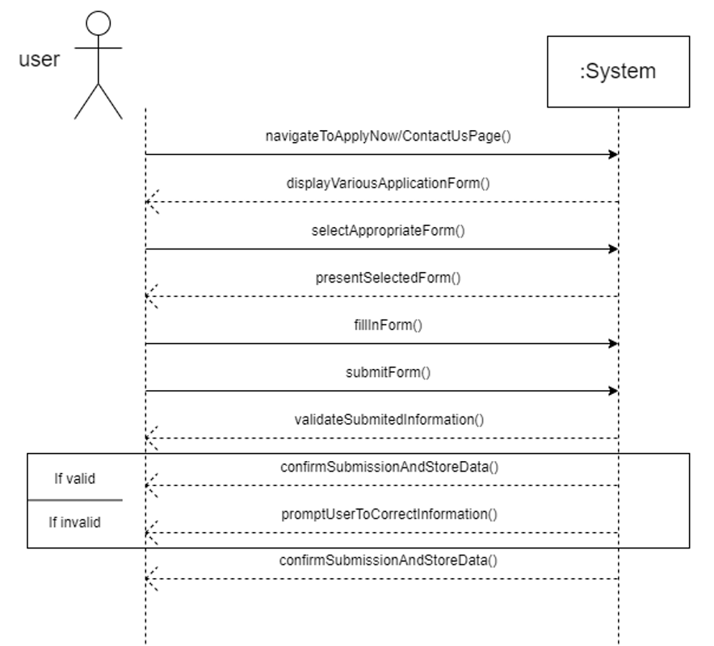

Use case 7: Fill Out Donation Form

